# Prospect-R Site and Administration Guide

## Table of Contents:

## The Site

### Header

### Logging In

### About

### Before you get started...

### FAQ

### Homepage

### Page Layout

### Map Panel

### All Sites

### Creating A New Site

### Drawing

### Editing

### Site Details

### Creating/Editing Pits

### Survey

### Report Summary

### Full Report

### Printable Report

## The Site: Prospect-R

Prospect-R is a tool for determining a gravel pit mine's viability for restoration. Using open source software, this tool was custom built for The Nature Conservancy by Ecotrust. It employs many cutting-edge technologies and methodologies to bring a science-based approach for decision making.

Users of Prospect-R will be able to register, log in, enter data about any given gravel pit, and receive a report detailing its viability for restoration. They can share a report link, print out their results or save them as a .pdf.

Using Bayesian logic, the tool is able to determine how likely a site is to be worth restoration even when not all information about the site is available. Note that it's a still probabilistic model, and will return a better answer with more data.

### Header

The page's header will stay fairly consistent during the entire site's workflow, only a few elements will change as they become or stop being relevant to the user's experience.

#### Site Name:



First and foremost is the site name and graphic. At any time while using the tool a user may click here and return to the title page (covered later).

#### Gravel Pit Site Name



If the user has a gravel pit site selected and are actively working on or viewing it, its name will be promptly displayed next to the Site Name.

#### Site Menu:

#### 

The Site Menu allows easy navigation for managing several gravel pit sites at once.

* 'Documents' - brings the user to a page listing useful documents they may wish to reference for answering questions about their gravel pit
* 'Add a site' - lets users add a new site to their project portfolio
* '{Site Name}' - in this case, 'Gravel Pit Site', an entry for every site the user creates will be in this list to quickly and easily switch between managing them.
* 'All sites' - Brings the user to the 'All Sites' page (covered later) where they can browse their gravel pit mine site projects.

#### Questions Menu:

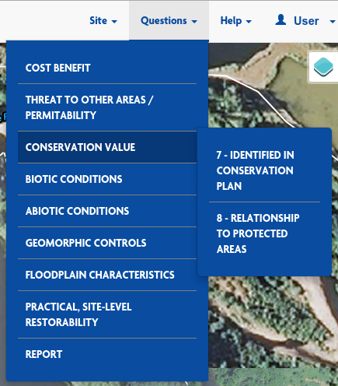

From the questions menu users will be able to access any of the survey questions as organized by their categories.

There is also one final item on the Questions Menu to allow the user to quickly reach their Report Page (once they've taken the survey).

#### Help Menu:

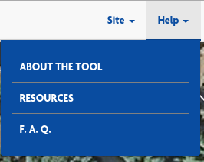

The Help Menu allows users at anytime access resources to help them in the event that they may have uncertainty about how to proceed with the tool.

#### User Menu:

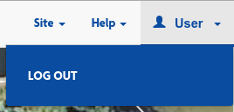

If logged in, the user's username will be printed here, otherwise it will simply read "Log In". Account-related actions (such as logging in or out) are accessable here.

### Logging In

Apart from the landing page and help pages, the rest of the site requires you to be a logged-in, registered user. The Accounts section has 3 different forms available to non-logged-in users: Log in, Reset Password, and Sign up/Register.

#### Sign Up:

Anyone is allowed to sign up. To register, simply access the accounts pages with the "Log in" button or the "Get Started" button on the home page. From the 'Log In' page, new users are directed to register via a link in the text, from the 'log in' menu in the header, or by clicking "I need to register" in the footer.

To sign up, a user only needs to provide a username, an optional email address, and a password for their own use. Once done, they will automatically be logged into the site, and if they provided an email address, they will receive a confirmation email. The user does not need to act on the confirmation email, but we will have records indicating whether a user has verified their email account or not.

#### Log In:

Once a user has registered with the site, they may log in at any time. The Log in page can be reached either from the Log In link in the header, or by clicking "Get Started" on the home page. Entering in their username and password will take them to their Sites page.

From the Log In page, users may also reach the Sign Up/Register page, or the Reset Password page.

#### Reset Password:

Users who do not remember their username or password can go to the Password Reset page, accessible from either the Sign Up or Log In pages. All they need to do is enter the email address they provided upon registration and they will be emailed instructions on how to reset their password and log in with their new credentials.

NOTE: supplying a password during registration is optional - if a user does not provide one, they will have no way to change their password, nor will they have a way to verify who they are to an administrator to change their password for them. Their only remaining options will be to try to remember their password or create a new account and start over.

### About

The about page is available to explain the purpose and audience of the site, as well as some of its functionality to all visitors, in case they don't know.

### Before you get started... / Documents

This page presents a list of documents and figures that will help users accurately answer the site's questions about their property and pits.

### FAQ

This page will be devoted to answering many of the most commonly asked questions about the site.

### Homepage

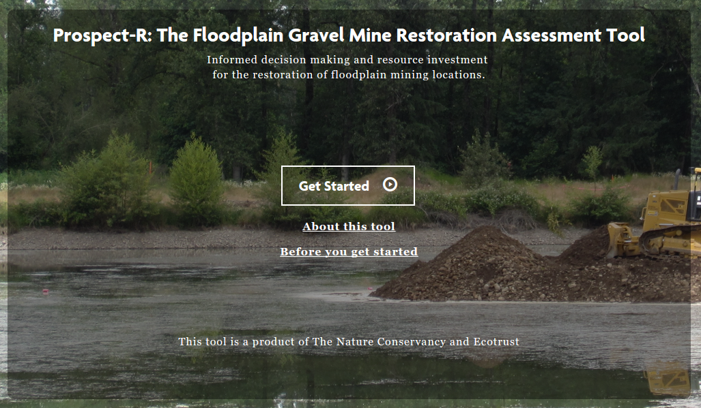

This is the default landing page for the site. It briefly conveys the purpose of the site and invites visitors to dig deeper, offering several links to further information and prominently displaying the path to "Get Started" with the site. It is reachable via link from almost every page in the tool.

### Page Layout

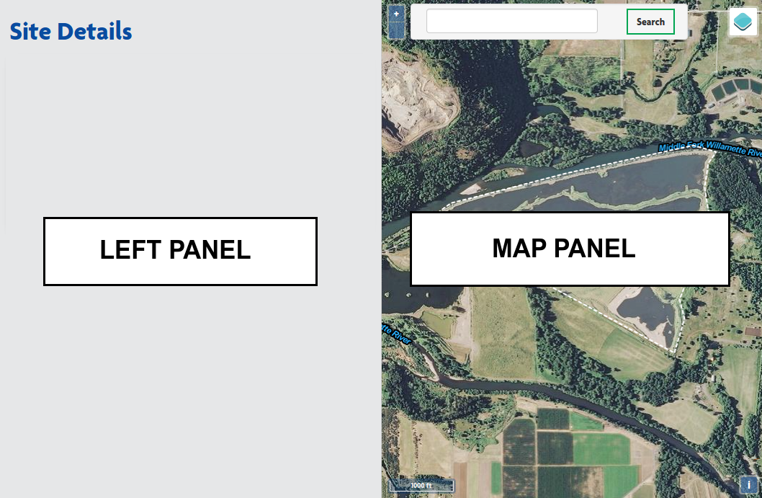

When users reach the All Sites page for their first time, they will be presented with the two primary components that drive most of the pages is this tool:

* The Left Panel - This panel provides context and all direction that users will need to get through the tool
* The Map Panel - This panel is a fully explorable map that will aid users in answering questions, and allow them to enter spatial information when that is requested. Mor on the map panel will be explained in its own section below.

### Map Panel

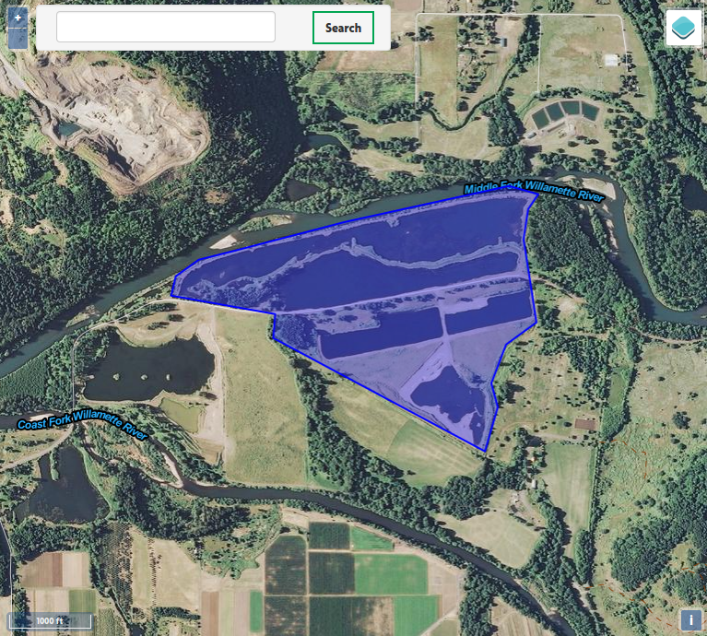

The map panel gets used for a variety of purposes. First and foremost it gives users quick and easy to understand context as to what geographic area they are answering questions for at any time (whether the question is about a pit mine or the site as a whole, etc...).



Map Controls: The '+' and '-' buttons relate to zooming in and out respectively. A user may also use the scroll-wheel on their mouse if they have one.

Panning or moving the map (left, right, up, down) is done by clicking and dragging with the mouse. There are no buttons for it.

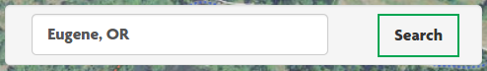

GeoSearch Bar: The search bar allows users to quickly navigate and zoom to nearby cities or landmarks.



Overlays: This button opens the overlay list on hover (more below)

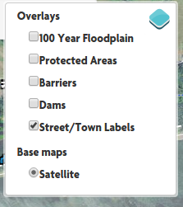

Overlay List: The checkboxes allow a user to add or remove layers from the map.

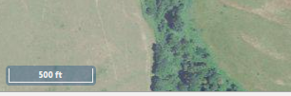

Scale Bar: In the bottom left, the user is given the scale of the map.



Attributions Button: Clicking this button opens the map's attributions display (below).



Attributions Display: A brief attribution of where map data is coming from.

### All Sites

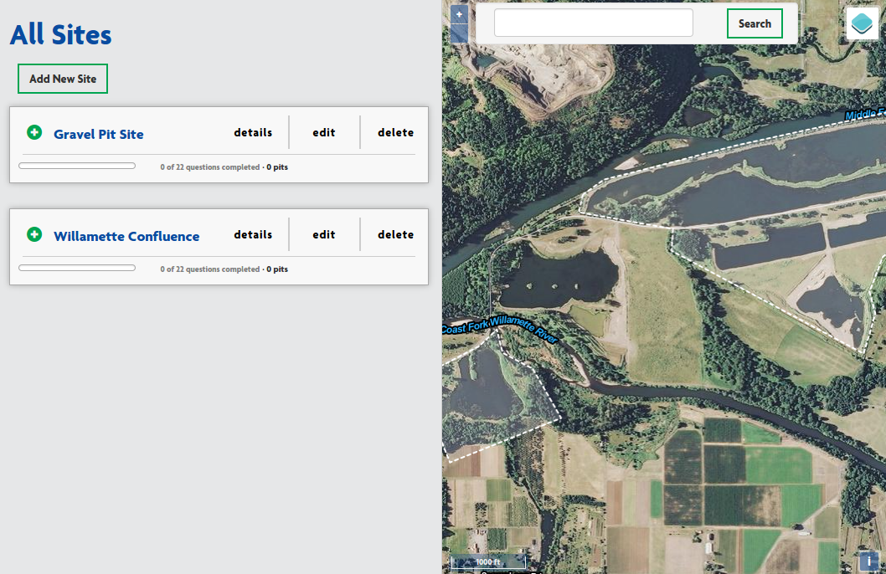

The left panel of this page provides users with a list of all of the site projects that they've entered into the tool. In this tool, a "Site" is a contiguous plot of land that encompasses one or more gravel pit mines.



If a user has not started any sites, they should click on the "Add New Site" to get started.

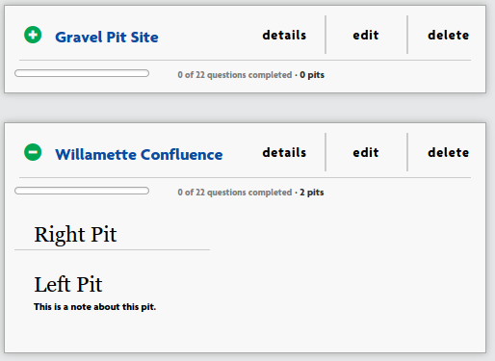

If the user has started one or more sites, they will see a list like this. All sites will show their name, progress toward answering questions about the sites, and have buttons for viewing, adding or editing information about the site.

Clicking on the site's name will display more information about it, such as what pits have been added to the site (see the 'Willamette Confluence example).

Clicking 'details' will bring you to the Site Details page (more below).

Clicking 'edit' will bring you to the Site edit page, where you can change the lines and name of your site (more on editing shapes later).

Clicking 'delete' will prompt you to confirm that you wish to delete the Site, including all pits, answers, and reports associated with it. Clicking 'OK' in the confirmation popup will instantly proceed with the deletion.

### Creating A New Site

This is the user's first chance to enter spatial data about their site. They will be drawing the geographic bounds of their site.

First, you will want to type in a name for your site. This name should be descriptive enough for you to know it from any of your other sites. It will show up in your reports, but is mostly used for reference. It does not have to reflect any official documentation.

After naming your site, you will need to draw out the boundaries for your site. Please note that 'Site' and 'Pit' are different: you will get to draw a boundary around any gravel pit mines you want assessed in later steps. For now, just choose a plot of ground big enough to cover your pits - some extra space around the pits is expected, and will make for clearer reports. If the property is much larger than just the gravel pits, PLEASE DO NOT TRACE THE ENTIRE PROPERTY. Just the area implicated in restoration plans is fine.

The actual drawing is covered in detail below.

Clicking Save will create your new site, which will add it to the "all sites" list mentioned earlier. Your site will not save if you have not drawn its boundaries like the example shown above, or if you have not given it a name. You will be prompted if you forget either of these.

Clicking "Cancel" will immediately discard any unsaved changes (no prompt). If you have not previously saved this site (as in, you are creating this site for the first time) then you will not have a site to show for it. If you are editing an existing, previously saved site (more details below) then you will only discard your newest, unsaved changes and revert to the original.

At the bottom, some helpful vocabulary and definitions are given to clarify any ambiguity in the tool's use of words:

**Site**: A contiguous plot of land that encompasses one or more pits.

**Pit**: A single gravel pit mine.

### Drawing

Drawing your bounds is relatively straighforward - just follow along the printed directions in the left panel on the map over your Site:

#### **Click anywhere on the map to start defining your general location boundary.**

#### Single click, in this case. You will want to actually click on your boundary to start, as wherever you click will be considered part of your site. Clicking inside of where you want to draw your boundary is a mistake that will become clear in the next step. **Continue clicking to complete the shape of your location.**

#### Each click will create a new 'corner' or 'vertex' for your shape. If you haven't done this before it sounds a bit confusing, but you'll get the hang of it quickly - just think of it as creating your own 'connect-the-dots' shape. As you click, you will see the border follow your mouse pointer.

#### In the screenshot below, the user is about 3/4 through drawing in a counter-clockwise pattern. Note that back-tracking or crisscrossing will leave you with a very distorted and useless shape. Always trace the outline, and "connect-the-dots" in that order.

#### There is no need to be perfect or overly detailed with the outlines. It's good enough if the boundary gives a general sense of the landscape, but this doesn't have to match survey lines.

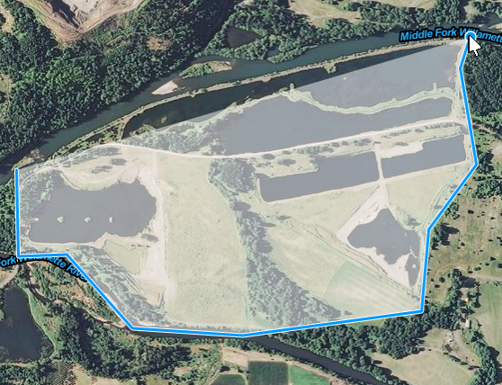

**When you're satisfied with your location outline, *double-click* to end drawing.**

You will know that you're done drawing when the shape is filled in with a transparent blue and the boundary line is no longer 'stuck' to your mouse pointer.

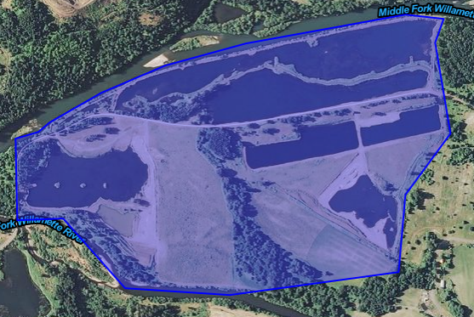

**Name and save your location when done. You can come back and edit this at any time.**

This is done by entering a name for your site (not a name for your pit(s) yet) and clicking the "Save" button.

### Editing

Editing a site or pit isn't very different from creating it to begin with, but is still much easier than recreating the site or pit if you already have some time invested in it, such as answered questions, or a complicated shape.

Editing the name of the shape is easy - simply edit the text in the "Name" field provided.

Editing the shape is a bit different. Unlike the 'Drawing' section, the shape of the boundary already exists. Once again, imagine the shape as a 'connect-the-dots' drawing. To change the drawing, you have two options: move existing dots, or add new dots. In this case, we refer to the dots as 'vertices' or a single dot as a 'vertex'.

Moving a vertex:

First you must locate the vertex you want to move. Sometimes they are clear, like a corner:

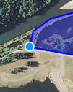

The blue dot is clearly a vertex, or the shape would have no corner here.

Some vertices are a little less obvious, depending on your shape's boundary. In this example, I have a vertex that is almost imperceptible here:

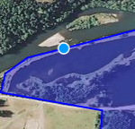

A good way to find vertices like this is to run your mouse pointer along the border without clicking anything. You'll notice that the blue dot follows your pointer's tip closely, but on occasion, and always at corners, it will try to stick, or 'snap' to one spot on the border - this makes it easier to grab vertices to move them. You don't have to get just the right pixel.

Once you've identified the vertex you want to move, simply click on it, drag it where you want it, and release. it will stay there, and you can watch the shape change as you go.

Creating a new vertex:

Creating a new vertex works just like moving an existing vertex, except that you can click anywhere on the boundary (other than on an existing vertex) to create it. Just click on the boundary where it's not quite right, drag the mouse pointer where you want the boundary, and release. Again you will see what the shape will look like in real-time as you move the new vertex.

Once done, be sure to click the 'Save' button to make your changes permanent. You will be allowed to edit them as many times as you want.

### Site Details

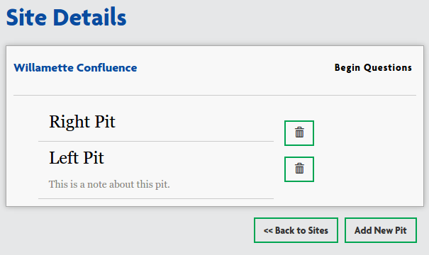

This page is the launching point for managing a site to be assessed for restoration. From here you can click "Add New Pit" to draw and describe the gravel pit mines on the site (covered in the next section), you can see the names of pits you've already added to the site and any notes you included about the pits, you can delete existing pits, you can begin answering questions about the site (details are covered later in this document), or you can click "<< Back to Sites" to return to the All Sites page.

If you have already answered some questions about this site, the "Begin Questions" button will be replaced by a "Go To Summary" button, and a "Continue Questions" button.



While the original "Begin Questions" button will take you to the first question in the series, clicking on "Continue Questions" will take you to your first unanswered question.

"Go To Summary" will take you to your report summary page, which will give you a brief look at how your site is shaping up. Note that if you have not finished answering all of the questions that you have information for, this summary is not necessarily accurate. More on this will be covered in the Report Summary section

### Creating/Editing Pits

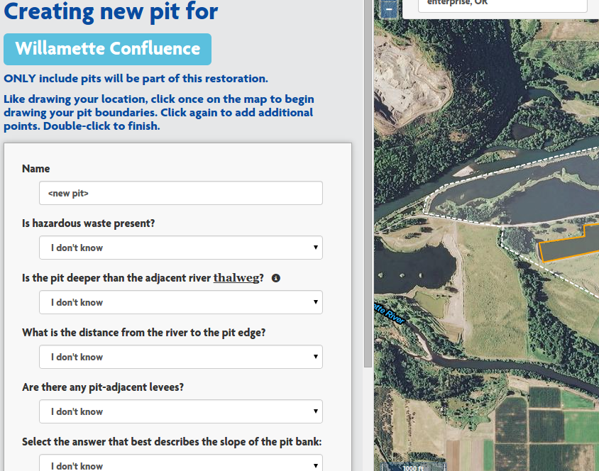

Since this tool is for assessing the restorability of sites with gravel pit mines within the floodplain, it is assumed that your site will have gravel pit mines on it, and your site will not get a good score without them.

Adding a pit to your site is a mixture of answering questions about each pit, and drawing the boundaries of your pit. Apart from naming the pit and adding notes, all of the questions are multiple choice.

Drawing your pit outline accurately is a bit more important than your site boundary, as part of your pit score is related to the size and shape of your pits: values determined by your drawing.

As with creating sites, the pit will not be added to your site until you click on the 'Save' button at the bottom. Editing also follows the same rules covered in the "Editing" section above.

### Survey

By clicking on either the "Begin Questions" or the "Continue Questions" button on a site's Details page, you can access the first unanswered question in the series. However, one you have selected a target site from the All Sites page, you will be able to navigate to any question at any time in the header using the questions menu in the Header (explained above).

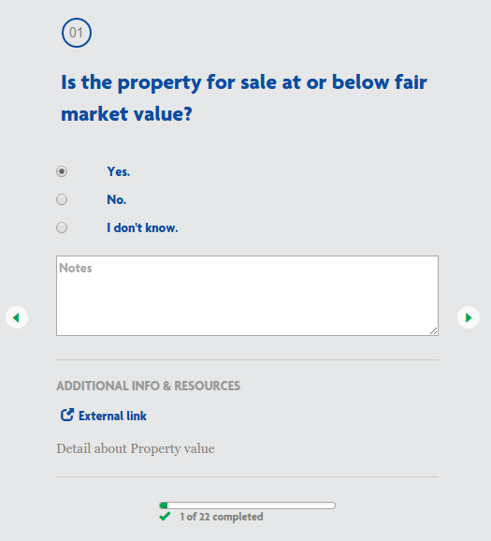

Each question gets its own page. At the top you can see the question number, followed by the question itself. Just below the questions will be the available answers - all answers will be multiple choice.

Each question also allows you to enter in some notes about the question or the answer for your own reference. Sometimes a question may not seem to have a clear answer, and so you will want to return to it after reviewing your materials or the help pages on this site. This notes section will help you maintain your train of thought in these cases. It will not play in to your final score.

Sometimes questions may have additional information or resources to help you fully understand the question. If so, links such as the "External link" shown here will appear below the notes section. There will often be an additional blurb explaining some nuance or terminology in the question below. In this case there is just placeholder text "Detail about Property value".



Navigating between questions is done with the left and right arrow icons on the sides of the left panel. The left arrow will take you back to the previous question (or the details page if on question 01) and the right arrow will take you to the next question (or the report summary page if you are on the last question).



At the bottom of the panel you will find the survey status bar. As you progress through the questions this bar will display your progress so you can have a feel for either how much further you have to go, or if you've answered all of the questions you have answers for, an idea of how much information will not be fed into the model to assess your site.

### Report Summary

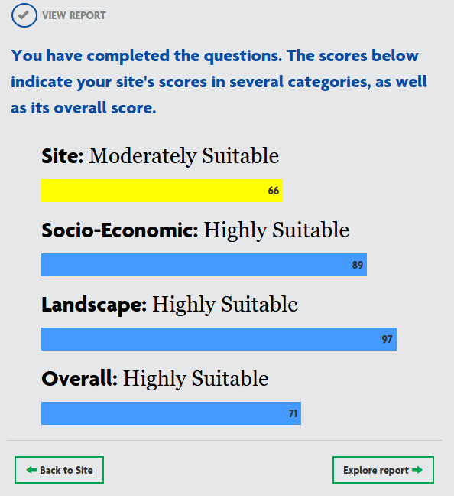

In a site's Report Summary page, you will get a broad overview of how your site was assessed. Your site is scored against 4 metrics: the physical characteristics of the Site itself, Socio-Economic factors to consider in taking on this restoration project, the landscape as a whole, and a final overall score.

Sometimes scores may be a bit surprising, but keep in mind that the scores are based on a Bayesian Belief model which is built to adjust for unknowns. Some answers on some questions will carry a tremendous amount of weight if paired with certain answers for other questions. Due to this variability, it is possible for your "Overall" score to be the lowest of the bunch, not just an average as one would expect. This is why it is important to gather as much information about your site as possible.

From this page, you can either return to the Site Details page via the "Back to Site" button, or you can go on to the detailed "Full Report" with the "Explore report" button.

### Full Report

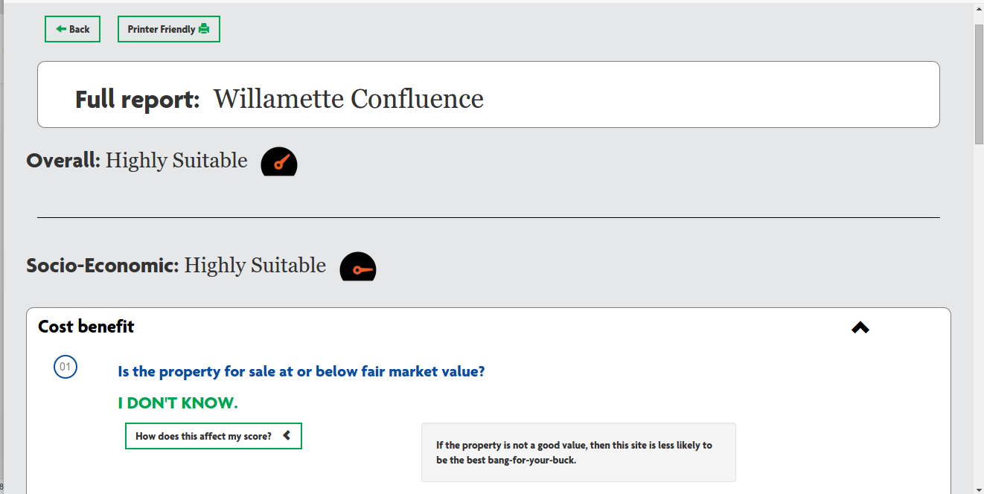

On this page you will be able to dig in and fully understand your score. You can review every answer you gave, and by clicking on "How does this affect my score?" you can get some insight as to why some questions are so important and may carry different weight than others, and how they may relate with other answers to result in your score.

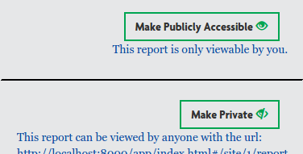

You also have the ability to share the report, either by using the 'Printer Friendly' button (covered in the next section) or by exposing your report to the public via a shareable web address. Clicking on the 'Make Publicly Accessible' button at the top right of the page will allow anyone who navigates to that report page to see your report – no need to even register. The web address can be copied either from the browser's address bar directly, or will be printed under the new button, 'Make Private' which will undo the change and prevent anyone but you from seeing the report.

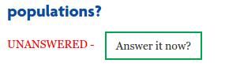

It is possible that you were not able to answer all of the questions, or that you forgot to come back and answer questions you had previously skipped. In the report, those answers will present a button to link you back to the skipped question so you can quickly answer it without digging through the other questions to find it.

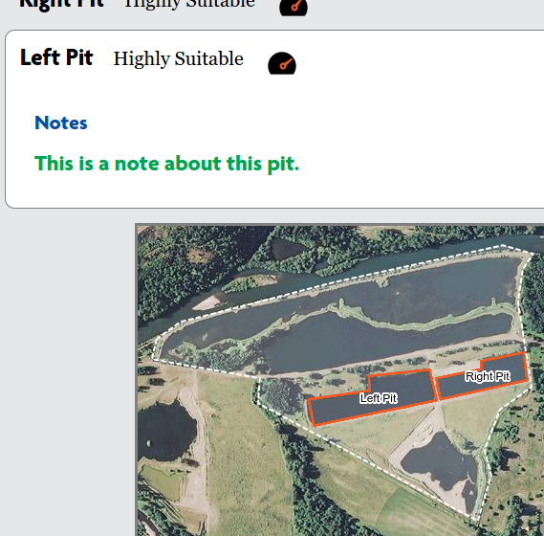

At the bottom of your report, you will find the pit details and a map of your pits included. It is good to remember that the assessment is for the restorability of all pits you list for the site. If your Location score is low, and you see one of your pits has a low score, perhaps you may want to assess restoration of the site without including that pit in the restoration. It is very possible in this case that deleting that pit from your site will raise your score, assuming you have other pits worth restoring on the site.

### Printable Report

From the Full Report page there is a button at the top marked "Printer Friendly":



This button will take you to a new view of the report that is much less stylized, but works very well being printed or saved as a .pdf to share.

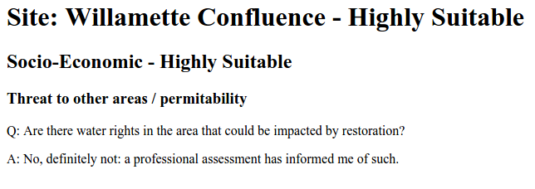

The styles are toned down and the colors are simplified - this will look better on paper and will conserve ink, not to mention that trying to print pages loaded with dynamic content, as the Full Report is, will not go well - to the point where it may be completely unreadable. This format is dependable and despite not being pretty, still contains the same information.

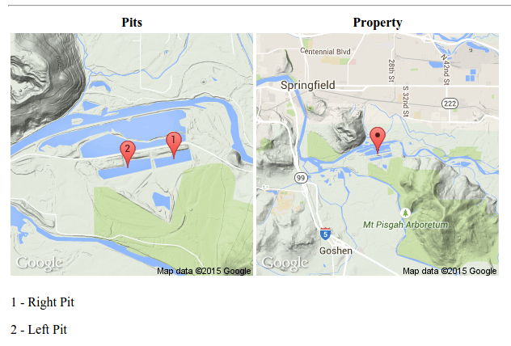

Despite the stripped down style and graphics, the printable page still has the pits and property mapped at the bottom, just in a printer friendly format.